Prepared by ICT302 PTA05
unit coordinator peter arthur richard cole | lecturer/tutor Loo Poh Kok
ICT302A
IT Professional Practice Project

Final Project
TOPIC: Design Document DesigDeDe
SUBMISSion date: 20240724 2359



School of Engineering and Information Technology
ASSIGNMENT COVER SHEET
Date: 20240508
Project Name: ICT302PTA05 IT Professional Practice Project
Name of Client Organization: Murdoch University ICT302A UC
Date of Document: 20240508
Version of the Document: 1.0
Group Name: PTA05
Member Details:
Role | Surname | Given Name | Student Number | Email | Whatsapp

Assignment details
Unit name | IT Professional Practice Project | Unit Code | ICT302
Unit Coordinator | Peter Arthur Richard COLE | Tutor/Tutorial time | Loo Poh Kok / Wed 7 pm
Due date/time | Friday Week 13 3 pm  2024xxxx 1500 | Submission date
Assignment title | ICT302A Final Project: Design Document
Other information | Murdoch login credentials:

All forms of plagiarism, cheating and unauthorized collusion are regarded seriously by the University and could result in penalties including failure in the unit and possible exclusion from the University. If in doubt, please contact the Unit Coordinator.

Student’s Declaration
Please double click on all the check boxes.

Except where I have indicated, the work I am submitting in this assignment is my own work and has not been submitted for assessment in another unit.

This submission complies with Murdoch University policies regarding plagiarism, cheating and collusion.

I have retained a copy of this assignment for my own records.

Table of Contents
Executive Summary 5
Introduction 7
Description of the scope and purpose of the document 7
Description of the document's intended audience 7
Identify the system/product using any applicable names and/or version numbers 8
Pertinent Documents References 8
Related and/or Companion Documents 8
Prerequisite Documents 8
Documents Providing Background and Context 8
Documents Resulting from this Document 9
Important Terms, Acronyms, and Abbreviations 9
Summary of the Contents of This Document 9
Data Design 11
Review and develop data objects, relationships, data flow and content 11
The Table Registration has to be built before the Table Login. 11
The Contact Us Form 12
The Volunteer Attendance Form 12
Case Report Form (Track Maintenance Report) 13
DATA DICTIONARY 13
Identify all data structures and the operations performed on them 13
Created the data dictionary to represent the relationships among data objects and the constraints on the elements of the data structure 14
DATA DICTIONARY 14
Database design 15
ERD 15
CREATE TABLE 15
Data-to-Process CRUD Matrix if applicable 17
Process Design 19
Detailed description of each software component: 19
Address processing controls 21
Architecture/Infrastructure Design 25
\Define the architecture of the system 25
Provide an architectural diagram if applicable (this can include the structure of static web pages, a guide to navigation). 28
Website version and Smart Phone version 28
Scalability: 28
Functions and Features 30
Scan Attendance 30
Track Maintenance Report – case report 31
GPS function 32
Camera and Video 33
Contact Us Form 34
Additional software components as necessary 35
Infrastructure requirements: 35
capacity 36
performance 36
integration & compatibility 36
platform strategy 36
security 37
back-up & recovery 38
scalability 38
future proofing 38
Discuss alternative designs 38
Interface Design 39
The design of the interfaces between software modules: 39
The design of interfaces between software and non-human (external) entities. 39
The design of the interface between human and computer (HCI) 39
Design Artefacts / Visuals 42
Data Flow Diagrams 42
Event Diagrams 42
Class Diagrams 42
Sequence Diagrams 42
Relevant Algorithms 45
Date and Time Calculations: 45
Backend Logic: 45
Frontend Validation: 46
Fetching and Displaying Data: 46
Expanded use-case narratives 46
1. User Registration 46
2. Attendance Logging 47
3. GPS Tracking 48
4. Contact Form Submission 48
5. Multimedia Capture (Photo Capture) 49
Conclusion 50
References 52
Appendices 52
Appendix A: Deliverable Task Breakdown Statement: completed, signed, scanned and copied into document 54
Appendix B: Glossary of terms and definitions and acronyms 55
Appendix C: data dictionary 56
Appendix D: Program Structure 57
Appendix E: Any other information you consider necessary to include 60

Executive Summary

The purpose of this document server an introductory guide to the design of the web mobile app development for BTF Track Maintenance App.

This document includes the following sections:

Introduction
Data Design
Process Design
Architecture / infrastructure Design
Additional Software Components
Infrastructure Requirements
Interface Design
Design Artefacts / Visuals
Data Flow Diagrams
Event Diagrams
Class Diagrams
Sequence Diagrams
Relevant Algorithms.

The Bibbulmun Track App (BTF) is an innovative web mobile application developed to enhance the experience of users navigating and reporting their activities on the Bibbulmun Track. Designed with modern technologies and a user-centric approach, the BTF app aims to streamline user interactions, improve data management, and integrate seamlessly with external systems to provide a comprehensive and efficient solution.

Purpose and Goals

The primary goal of the Bibbulmun Track App is to support users in tracking their journey, logging attendance, capturing and reporting issues, and staying safe through real-time GPS tracking. The app also facilitates communication between users and the track management team, ensuring that feedback and issues are addressed promptly.

Key Features

User Registration (Volunteer Profiles):

A secure and straightforward registration process that allows users to create personalized accounts.

Attendance Logging:

Efficient logging of check-in and check-out times, with automatic calculation of the duration spent on the track.

GPS Tracking:

Real-time location tracking to help users navigate the track safely and accurately.

Contact Form Submission:

Easy submission of contact forms to report issues, provide feedback, or request assistance.

Multimedia Capture:

Capability to capture and store photos, helping users document their experiences and report issues visually.

The development of the Bibbulmun Track App follows best practices in software engineering, ensuring a robust, maintainable, and scalable solution. The application is designed to be user-friendly, providing an intuitive interface and seamless user experience.

The Bibbulmun Track App is a comprehensive and reliable solution designed to enhance the user experience on the Bibbulmun Track. By leveraging modern technologies and incorporating user-centric features, the app ensures efficient tracking, reporting, and communication. The BTF app stands as a valuable tool for both users and track administrators, facilitating better management and enjoyment of the Bibbulmun Track.

This executive summary outlines the strategic vision and technological foundation of the Bibbulmun Track App, underscoring its role in improving the tracking, safety, and reporting capabilities for users navigating the Bibbulmun Track.

Introduction

Description of the scope and purpose of the document

This document provides a comprehensive overview of the Bibbulmun Track App (BTF), a web mobile application designed to enhance the user experience on the Bibbulmun Track.

The document outlines the architecture, design, and functionality of the app, detailing each software component, process model, and use-case narrative.

It also includes detailed descriptions of sequence diagrams, expanded use-case narratives, processing controls, algorithms, and class diagrams to ensure a clear understanding of the system's behavior and structure.

The purpose of this document is to serve as a reference for developers, stakeholders, and project managers involved in the development, maintenance, and enhancement of the Bibbulmun Track App.

Description of the document's intended audience

This document serves as a reference /user guide for all users of the BTF Track Maintenance App on both website and handphone versions.

This document is intended for:

Developers:
To understand the architecture, design, and detailed implementation of the Bibbulmun Track App.

Project Managers:
To get an overview of the project’s scope, goals, and system functionality.

Stakeholders:
To gain insights into the features and capabilities of the app and how it meets user needs.

Testers:
To use as a basis for developing test plans and test cases.

Technical Writers:
To document and update user manuals and help guides based on the system design.

Identify the system/product using any applicable names and/or version numbers

System/Product Name: Bibbulmun Track App (BTF)
Version Number: 1.0

Pertinent Documents References

Related and/or Companion Documents

Project Proposal Document:

RNA Research and analysis outlines the initial project scope and objectives.

User Requirements Specification (URS):

The client documents with the instruction manual and the demo video details the user requirements for the Bibbulmun Track App.

System Requirements Specification (SRS):
Technical Documents installation manual and user guide define the system requirements and constraints.

Design Specification Document (DSD):
Design Document provides the design details and architecture of the app.

Prerequisite Documents

The Client Document
User Guide, User Requirements Specification (URS)
Demo Video

Installation Manual
System Requirements Specification (SRS)

Documents Providing Background and Context

PMP Project Management Plans

Bibbulmun Track Official Website:
Provides information about the track and its significance.

Node.js Documentation:
Offers background on the server-side technology used in the app.

MySQL Documentation:
Provides context on the database technology employed.

Documents Resulting from this Document

Test Plan:

Based on the detailed process models and use-case narratives.

Development Plan:

Project Charter, PMP outline the development phases and milestones derived from the design specifications.

Attached RNA Research and Analysis
Background of the client’s business/organization – page 14

The Client Document / User Manual Demo Video:

Created using the functional and technical descriptions provided.

Important Terms, Acronyms, and Abbreviations

BTF: Bibbulmun Track App
CRUD: Create, Read, Update, Delete
GPS: Global Positioning System
HTML: HyperText Markup Language
CSS: Cascading Style Sheets
JS: JavaScript
Node.js: A JavaScript runtime built on Chrome's V8 JavaScript engine
MySQL: A relational database management system
API: Application Programming Interface
Appendix B

Summary of the Contents of This Document

This document is organized as follows:

Introduction:
Provides an overview, scope, and purpose of the document, intended audience, and related documents.

Architecture/Infrastructure Design:
Defines the architecture of the system and its components.

Process Models and Use-Case Narratives:
Includes detailed process models, expanded use-case narratives, and sequence diagrams for key functionalities.

Processing Controls and Algorithms:
Details the algorithms used and processing controls implemented in the system.

Class and Sequence Diagrams:
Provides high-level and low-level class diagrams and sequence diagrams to illustrate the system’s structure and behavior.

Conclusion:
Summarizes the key points and provides an overview of the system's benefits and functionalities.

This document serves as a comprehensive guide for the development, implementation, and maintenance of the Bibbulmun Track App, ensuring all stakeholders have a clear and detailed understanding of the system.

Data Design
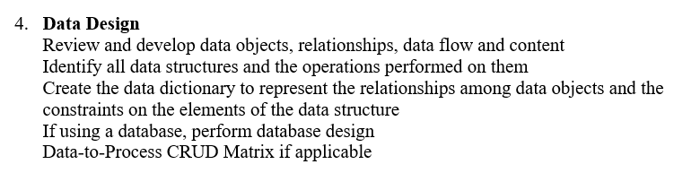

Review and develop data objects, relationships, data flow and content

The development of the web and mobile app using Cordova, and selected handy MySQL with Express for the database function. The MySQL WorkBench makes the database table creation a very simple and easy job.

The Table Registration has to be built before the Table Login.

Users need to build registration before they can use the login function.
This registration form spells out all volunteer profiles that the Client Terry needs.

Table: attendance
Columns:
IDattendance int AI PK
IDregistration int
chkInDTS datetime
chkOutDTS datetime
volHours decimal(10,2)
created_at datetime

Table: login
Columns:
IDlogin int AI PK
loginUserName varchar(45)
loginPassword varchar(45)
created_at datetime

The Contact Us Form

Contact Us form will send the user information to two areas:
1. Keep in the database
2. send out an email to the office administration.

Table: contactus
Columns:
IDcontactus int AI PK
name varchar(20)
email varchar(30)
subject varchar(45)
message varchar(255)
created_at datetime

The Volunteer Attendance Form

There is a “built-in” date time picker for the users to click for Check-In and Check-Out. The user can also use a QR code to scan for the time, and these date time will be registered in the system.

The system will calculate “Volunteer Hours Worked today” by using “Check-in date time” minus “Check-Out time”
This Volunteered Hours will be save in the MySQL data base, for today, and also in another field, “accumulated volunteered hours” that add on each time when the users click, or scan QR Code.

The management can use this information for the BTF and relevant authorities to reward the volunteers.

Table: attendance
Columns:
IDattendance int AI PK
IDregistration int
chkInDTS datetime
chkOutDTS datetime
volHours decimal(10,2)
created_at datetime

Case Report Form (Track Maintenance Report)

Table: casereport  Columns:  IDcasereport int AI PK  IDlogin int  reporterName varchar(20)  reporterContact varchar(20)  dateTimePicker datetime  decDist varchar(30)  campsites varchar(20)  issueType varchar(20)  issuetypeoptions varchar(20)  problem varchar(3)  severity varchar(10)  frequency varchar(10)  emailDEC varchar(30)  issueDescription varchar(255)  latitude double  longitude double  created_at datetime | Table: casereport_photos  Columns:  IDphoto int AI PK  IDcasereport int  photo blob  created_at datetime  Table: casereport_videos  Columns:  IDcasereport_videos int AI PK  IDcasereport int  video blob  created_at datetime

DATA DICTIONARY

Identify all data structures and the operations performed on them

Appendix C

Created the data dictionary to represent the relationships among data objects and the constraints on the elements of the data structure

DATA DICTIONARY

btf/www/index.html  form id="registration” | btf/www/index.html  form id =”login” | btf/www/html/contactus.html  form id="contactUs” | btf/www/index.html  form id="casereport” | btf/www/html/attendance.html  form id="attendance”
Table: registration  Columns:  IDregistration int AI PK  loginUserName varchar(20)  loginPassword varchar(8)  repeatPassord varchar(8)  fName varchar(20)  lname varchar(20)  eMail varchar(30)  hPhone varchar(20)  role varchar(10)  rLocality varchar(6)  fAddress varchar(90)  streetNumber varchar(3)  suburb varchar(10)  street varchar(30)  address1 varchar(30)  address2 varchar(30)  city varchar(5)  state varchar(20)  zipcode varchar(4)  volCat varchar(30)  tCert varchar(30)  background varchar(255)  created_at datetime | Table: login  Columns:  IDlogin int AI PK  loginUserName varchar(45)  loginPassword varchar(45)  created_at datetime | Table: contactus  Columns:  IDcontactus int AI PK  name varchar(20)  email varchar(30)  subject varchar(45)  message varchar(255)  created_at datetime | Table: casereport  Columns:  IDcasereport int AI PK  idLogin int  dateTimePicker datetime  decDist varchar(30)  campsites varchar(20)  issueType varchar(20)  issuetypeoptions varchar(20)  problem varchar(3)  severity varchar(10)  frequency varchar(10)  emailDEC varchar(30)  issueDescription varchar(255)  latitude double  longitude double  photo blob  reporterName varchar(20)  reporterContact varchar(20)  created_at datetime | Table: attendance  Columns:  IDattendance int AI PK  chkInDTS datetime  chkOutDTS datetime  volHours int  aVolHours int  created_at datetime

Database design

ERD

CREATE TABLE | DESCRIPTION
CREATE TABLE registration(  idUser INT AUTO_INCREMENT PRIMARY KEY,  name VARCHAR(50),  email VARCHAR(100) UNIQUE,  password VARCHAR(255),  created_at TIMESTAMP DEFAULT CURRENT_TIMESTAMP  ); | registration  IDregistration: Primary key, auto-incremented integer, unique identifier for each user.  fName: first name.  lName: last name  email: User's email, must be unique.  password: User's password, stored as a hashed string.  created_at: Timestamp indicating when the user account was created.
CREATE TABLE Attendance (  idAttendance INT AUTO_INCREMENT PRIMARY KEY,  idUser INT,  checkInTime TIMESTAMP,  checkOutTime TIMESTAMP,  duration INT, -- duration in minutes  FOREIGN KEY (idUser) REFERENCES Users(idUser)  ); | Attendance  idAttendance: Primary key, auto-incremented integer, unique identifier for each attendance record.  idUser: Foreign key linking to the Users table.  checkInTime: Timestamp for when the user checks in.  checkOutTime: Timestamp for when the user checks out.  duration: Calculated duration of the user's attendance in minutes.
CREATE TABLE GPSData (  idGPSData INT AUTO_INCREMENT PRIMARY KEY,  idUser INT,  latitude DOUBLE,  longitude DOUBLE,  timestamp TIMESTAMP,  FOREIGN KEY (idUser) REFERENCES Users(idUser)  ); | GPSData  idGPSData: Primary key, auto-incremented integer, unique identifier for each GPS data record.  idUser: Foreign key linking to the Users table.  latitude: Latitude of the user's location.  longitude: Longitude of the user's location.  timestamp: Timestamp indicating when the GPS data was recorded.
CREATE TABLE ContactUs (  idContact INT AUTO_INCREMENT PRIMARY KEY,  idUser INT,  message TEXT,  created_at TIMESTAMP DEFAULT CURRENT_TIMESTAMP,  FOREIGN KEY (idUser) REFERENCES Users(idUser)  ); | ContactUs  idContact: Primary key, auto-incremented integer, unique identifier for each contact message.  idUser: Foreign key linking to the Users table.  message: Text message submitted by the user.  created_at: Timestamp indicating when the message was created.
CREATE TABLE CaseReports (  idCaseReport INT AUTO_INCREMENT PRIMARY KEY,  idUser INT,  description TEXT,  created_at TIMESTAMP DEFAULT CURRENT_TIMESTAMP,  FOREIGN KEY (idUser) REFERENCES Users(idUser)  ); | CaseReports  idCaseReport: Primary key, auto-incremented integer, unique identifier for each case report.  idUser: Foreign key linking to the Users table.  description: Detailed description of the case report.  created_at: Timestamp indicating when the case report was created.
CREATE TABLE Photos (  idPhoto INT AUTO_INCREMENT PRIMARY KEY,  idCaseReport INT,  photoBlob BLOB,  FOREIGN KEY (idCaseReport) REFERENCES CaseReports(idCaseReport)  ); | Photos  idPhoto: Primary key, auto-incremented integer, unique identifier for each photo.  idCaseReport: Foreign key linking to the CaseReports table.  photoBlob: Binary data of the photo.
CREATE TABLE Videos (  idVideo INT AUTO_INCREMENT PRIMARY KEY,  idCaseReport INT,  videoBlob BLOB,  FOREIGN KEY (idCaseReport) REFERENCES CaseReports(idCaseReport)  ); | Videos  idVideo: Primary key, auto-incremented integer, unique identifier for each video.  idCaseReport: Foreign key linking to the CaseReports table.  videoBlob: Binary data of the video.

Data-to-Process CRUD Matrix if applicable

The Data-to-Process CRUD Matrix is a tool used in software development and database design to define and manage data interactions within an application or system.

CRUD stands for Create, Read, Update, and Delete, which are the four basic operations that can be performed on data.

Data Entities:
Identify all the major entities or objects in the system that need to be managed. These could be things like registration form (volunteer profiles), login function, case report function, attendance, contact us form.

Use Cases:
Identify the various processes or use cases within the system that interact with these data entities. For example, in this case, use cases might include preparing case report using GPS and Camera features.

CRUD Operations:
For each data entity, define which CRUD operations are applicable. Typically, this involves determining whether each use case needs to create, read, update, or delete data from each entity.

Matrix Creation:
Construct a matrix where rows represent the data entities and columns represent the processes or use cases. Within the matrix, mark or indicate which CRUD operations are associated with each data entity for each use case.

Analysis and Validation:
Review the matrix to ensure that all necessary data interactions are covered and correctly mapped. This helps in identifying potential gaps or inconsistencies in data handling across different use cases.

Implementation Guidance:
Use the matrix as a guide during the implementation phase to ensure that developers correctly implement data access and manipulation logic according to the defined CRUD operations for each process.

CRUD MATRIX
Create, Read, Update, Delete.
USER ROLES | Registration Data | Attendance | Case Report | Contact Us
Admin  (Terry K.) | C, R, U, D, | C, R, U, D, | C, R, U, D, | C, R, D
Volunteers | C, R, U, | C, R, | C, R, U | C,
Public |  |  | C, R, U, | C,

Process Design

Detailed description of each software component:

The break-down of the software components into
process models,
process descriptions using structured English,
expanded use-case narratives, and
decision tables where applicable.

1. Process Models
Data Flow Diagrams (DFDs)
Level 0 DFD:
Provides an overview of the entire system showing high-level processes such as user interaction, data storage, and external entities (users, databases, GPS systems).

Level 1 DFDs:
Break down each major process from the Level 0 DFD into more detailed subprocesses and data flows.

Example components:

User registration, attendance logging, GPS tracking, contact form submission, multimedia capture (photos/videos).

Event-Driven Models

Decomposition Diagram:

Illustrates how high-level processes are broken down into smaller, manageable subprocesses.

Shows relationships and dependencies between events and processes within the system.

Event Response Diagrams:

Describe how the system responds to specific events triggered by users or external systems (e.g., data submission, login/logout events).

Use Case Lists:

Detail specific user interactions with the system, highlighting each action a user can take and the corresponding system response.

Example use cases:

User registers, logs attendance, submits contact form, captures photos/videos, views reports.

2. Process Descriptions (Structured English)
Structured English:
Detailed descriptions of processes using structured pseudo-code.

Example:
sql
Form: registration
Process: User Registration
1. User enters registration details (name, email, password etc.,).
2. System validates input data (checks for uniqueness of email, password complexity).
3. If data is valid:
a. Create user account in the database.
b. Send confirmation email to the user.
4. If data is invalid:
a. Display error messages to the user indicating validation issues.
5. End process.

3. Expanded Use-Case Narratives

Expanded Use-Case Narratives:

Elaborate on each use case scenario, providing detailed steps, preconditions, postconditions, and alternative flows.

Example for " Registration":
Preconditions: User accesses registration page.

Main Flow:
User enters registration details.
System validates input.
User account is created.
Confirmation email is sent.

Alternative Flow:
Invalid data entered;
system displays error messages.

4. Decision Tables

Decision Tables:
Represent complex business rules or logic using a tabular format.

Example for user registration:

Condition Action
Valid data Create user account
Invalid data Display error messages
Existing email Prompt user to choose new email
Password weak Require stronger password

Each component plays a crucial role in defining, describing, and modeling the processes and interactions within the Bibbulmun Track App. These structured models and descriptions ensure clarity in system behavior, aid in development, and serve as a reference for stakeholders involved in the project. They help in understanding how users interact with the system, how data flows through different processes, and how decisions are made based on specific conditions. This structured approach facilitates effective communication, development, and maintenance of the application throughout its lifecycle.

Address processing controls

Addressing processing controls in the context of the Bibbulmun Track App involves detailing algorithms, structure charts, hierarchy charts, and potentially using Object-Oriented Modeling and Design (OOM/D) concepts like class diagrams and sequence diagrams. These components are crucial for understanding how data is processed, controlled, and managed within the application.

1. Algorithms
Algorithms in the Bibbulmun Track App define the step-by-step procedures for various operations, such as data validation, database interactions, and user interactions.

Here are some example algorithms relevant to the application:

Example Algorithm: User Registration Validation
Algorithm: ValidateUserRegistration
Input: user details (name, email, password)
Output: validation result (valid or invalid)

1. Check if the email format is valid.
2. Check if the email is unique (not already registered).
3. Check password complexity (minimum length, special characters).
4. If all checks pass:
a. Return "valid".
5. If any check fails:
a. Return "invalid".

2. Structure Charts
Structure charts illustrate the modular structure of the software components and how they interact with each other. They show the hierarchy of modules and their dependencies.

Example Structure Chart: User Management Module

User Management Module
|-- ValidateUserRegistration
|-- CreateUserAccount
|-- UpdateUserDetails
|-- DeleteUserAccount

3. Hierarchy Charts
Hierarchy charts visualize the hierarchical relationships between different components or modules in the system, providing a clear understanding of their organizational structure.

Example Hierarchy Chart: Application Components

Application
|-- Frontend
| |-- HTML Pages
| |-- CSS Stylesheets
| |-- JavaScript Files
|-- Backend
| |-- MySQL Database
| |-- Server-Side Scripts
| |-- Photo-Video Handling
|-- External Interfaces
| |-- GPS Tracking System
| |-- Email Service

4. Object-Oriented Modeling (OOM/D)

Using OOM/D involves class diagrams and sequence diagrams to model the system's object-oriented structure and interactions.

Class Diagram

A class diagram illustrates the classes, attributes, methods, and relationships between objects in the system.

Example Class Diagram: User Management

Registration

| - IDregistration: int
| - fName: string
| - lName: string
| - email: string
| - loginPassword: string

| + register(): void
| + updateDetails(): void
| + deleteAccount(): void

Sequence Diagram

Sequence diagrams show the interactions / relationship between objects in a chronological sequence, depicting the flow of messages and method calls.

Example Sequence Diagram: User Registration

Registration --> Frontend: Enter registration details
Frontend --> Backend: Send registration request
Backend --> Backend: Validate user data
Backend --> Database: Check email uniqueness
Database --> Backend: Return validation result
Backend --> Frontend: Display validation message

5. Data Dictionary
A data dictionary provides detailed definitions of data elements used in the system, enhancing clarity and consistency in data processing.

Example Data Dictionary Entry: User Table

Table: registration
Columns:
IDregistration int AI PK
loginUserName varchar(20)
loginPassword varchar(8)
repeatPassord varchar(8)
fName varchar(20)
lname varchar(20)
eMail varchar(30)
hPhone varchar(20)
role varchar(10)
rLocality varchar(6)
fAddress varchar(90)
streetNumber varchar(3)
suburb varchar(10)
street varchar(30)
address1 varchar(30)
address2 varchar(30)
city varchar(5)
state varchar(20)
zipcode varchar(4)
volCat varchar(30)
tCert varchar(30)
background varchar(255)
aVolHours int
created_at datetime

Processing controls in the Bibbulmun Track App ensure that data is managed securely and efficiently throughout the application.

Algorithms define specific operations, structure charts illustrate module interactions, hierarchy charts show component relationships, and OOM/D provides detailed class and sequence diagrams for object-oriented modeling.

Together with these components enhance understanding, facilitate development, and support effective management of the application's processing controls.

Architecture/Infrastructure Design

\Define the architecture of the system

The app development using Cordova on Node.js with Express, that is able to serve on both website and smart phone using html, javascript and css. The app is able to serve both offline and online. While offline, it can store the information on local storage (on the handphone), and when it reaches place with internet connection, it can synchronise to send data to the databases, or sent email to the DEC District.

The architecture of the Bibbulmun Track App (BTF) encompasses both its overall design and infrastructure setup. Hereby define the architecture focusing on its components, layers, and how they interact to support the application's functionalities.

Architecture Overview

1. Client-Side (Frontend)

HTML, CSS, JavaScript:

Responsible for the presentation layer and user interface components. They handle user interactions, form submissions, and display of data.

Components: www/html/, www/css/, www/js/

2. Server-Side (Backend)

Node.js Environment:

Provides the backend runtime environment for executing server-side scripts and handling HTTP requests.

Components: MySQL-backend/, photo-video-backend/

Database (MySQL):

Stores and manages application data, including user information, attendance logs, contact forms, and multimedia files.

Component:

MySQL database (bibbulmun_track_app)

3. Communication and Integration

APIs:
Define interfaces for communication between frontend and backend components, enabling data exchange and functionality execution.

Endpoints:
Defined in backend server scripts (server.js in MySQL-backend/ and photo-video-backend/)

4. External Integrations

GPS Tracking System:

Interface with external GPS systems to capture and display location data related to the Bibbulmun Track.

Component:

Integration handled in server-side scripts (server.js)
5. Infrastructure

Hosting Environment:

Deployment on a server infrastructure capable of running Node.js applications and supporting MySQL databases.

Deployment:

Hosted environment setup for deployment (www/, MySQL-backend/, photo-video-backend/)

Detailed Components

Frontend Components (www/ Directory)

HTML Pages (www/html/):
Various pages like index.html, attendance.html, clickGPS.html, contactUs.html, loginLanding.html, registration.html for different application features.

CSS Stylesheets (www/css/):
Styling for the frontend components to ensure a cohesive and user-friendly interface.

JavaScript Files (www/js/):
Client-side scripts (app.js, attendance.js, clickGPS.js, contactUs.js, etc.) handling user interactions and data manipulation.

Backend Components (MySQL-backend/ and photo-video-backend/ Directories)
Node.js Server (server.js):
Backend logic and API endpoints (MySQL-backend/server.js, photo-video-backend/server.js) handling data processing, business logic, and database interactions.

MySQL Database (bibbulmun_track_app):
Centralized storage for application data (registration, attendance, contactus, reports, users tables).

Architecture Design Principles
Modularity:
Components are modularized (www/, MySQL-backend/, photo-video-backend/) for easier maintenance and scalability.

Scalability:
Designed to handle increasing user base and data volume, leveraging Node.js asynchronous nature and MySQL's scalability options.

Security:
Implementing data encryption, user authentication, and access control measures to protect user data and application integrity.

Performance:
Optimizing database queries, client-server communications, and frontend rendering to ensure responsiveness and efficiency.

Deployment
Hosting Platform (Github):
Deployed on a reliable hosting platform capable of supporting Node.js applications and MySQL databases.

Continuous Integration/Deployment (CI/CD):
Integration of automated deployment pipelines to streamline updates and ensure consistency in deployment.

The architecture of the Bibbulmun Track App integrates frontend, backend, database, and external system components to deliver a comprehensive application for tracking, reporting, and managing activities related to the Bibbulmun Track. It employs modern technologies like Node.js and MySQL, ensuring scalability, security, and performance while providing a seamless user experience through its frontend interfaces and backend functionalities.

This architecture supports the application's objectives of user engagement, data management, and integration with external systems such as GPS tracking.

Provide an architectural diagram if applicable (this can include the structure of static web pages, a guide to navigation).

Website version and Smart Phone version

Both Website and Smart phone has the same function because they are built on one system platform leverage on cordova technology

To use it on the handphone, simply scan the QR code on the website, or the marketing staff can promote this handphone app by supplying the QR code at the suitable prominent locations, even along the track with connection.

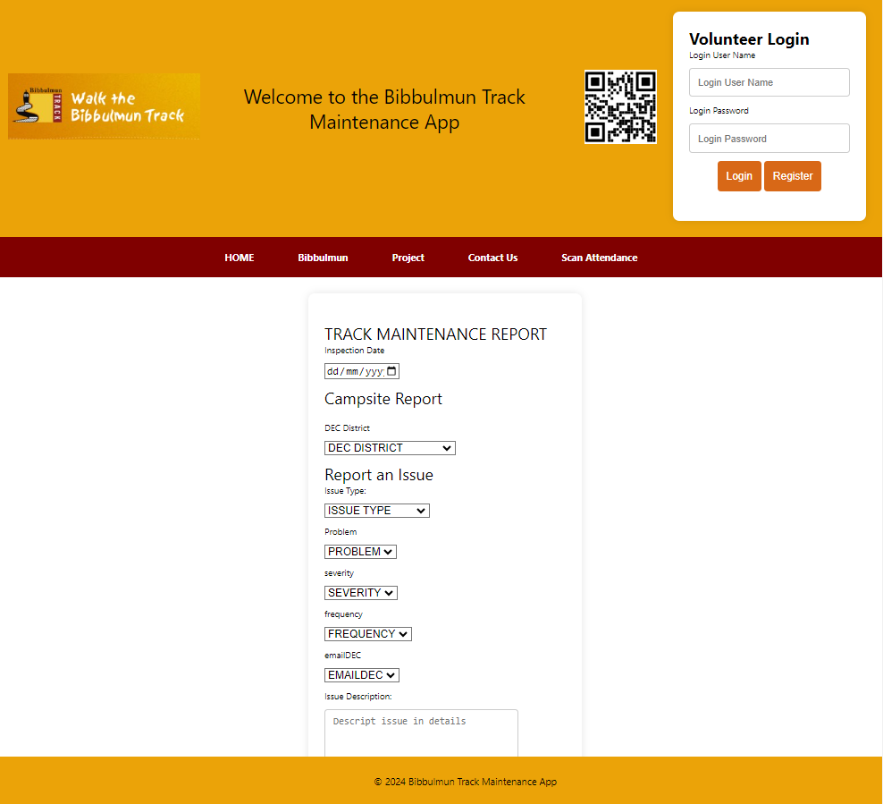

Scalability:
The development of the web and mobile app is built on the basic of the extension to the BTF existing website.

Extension of the Login / Registration

By adding in a login and registration link from the BTF existing website, and when the users click on that link, it can come to this database with this white box of “login” and “registration” function on the landing page.

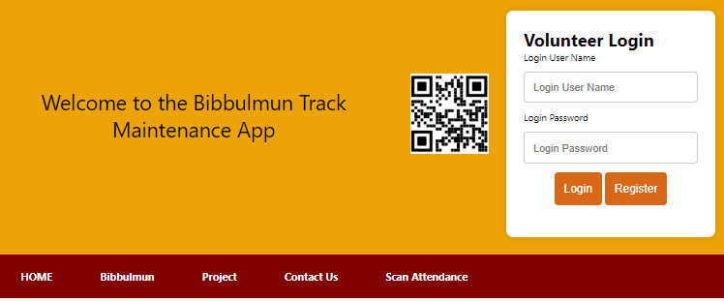

Linking back to the BTF existing website

The 2nd tab on the website’s navigator link directly to various (four) pages of the BTF existing website, namely walk the Bibbulmun Trac, Volunteer with us, Training and recognition, Volunteering FAQs. The user can visit the entire BTF existing website within a click in a well-organized sequence.

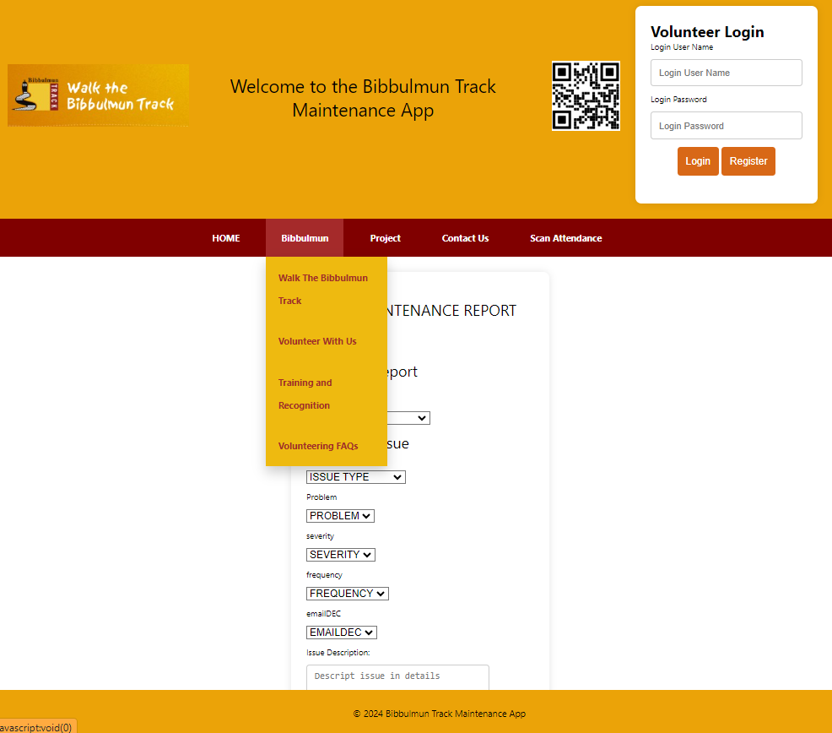

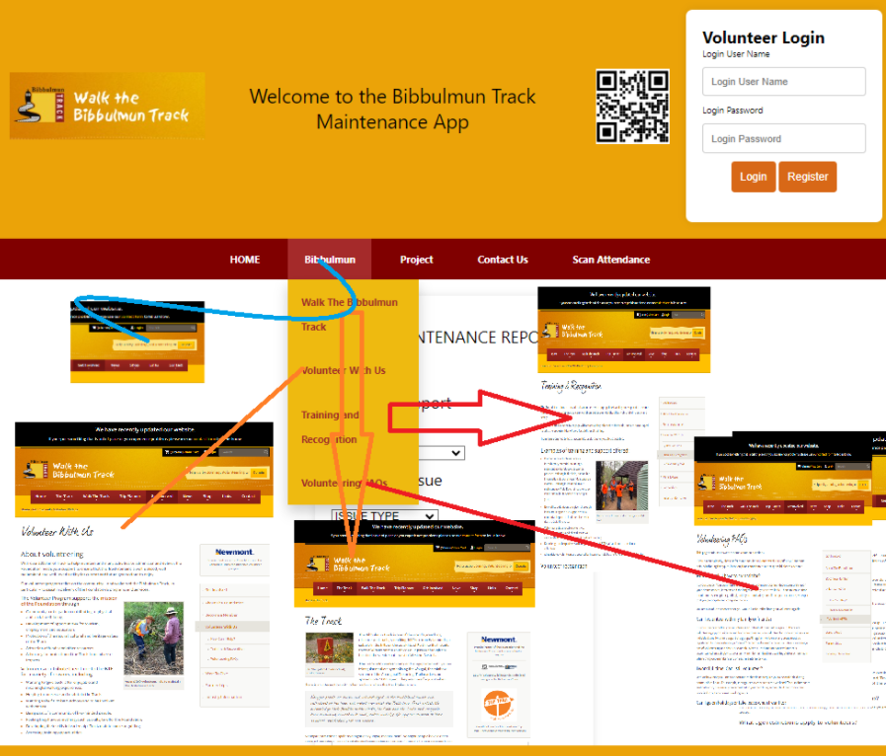

Functions and Features

Scan Attendance

Volunteers can either scan on QR code, or click on the Date Time Picker for Check in and Check out. The system compute automatically the number of hours they work on this trip, and add on to the “accumulated volunteered hours” in the system.

This assist the BTF and relevant authorities to rewards the volunteers.

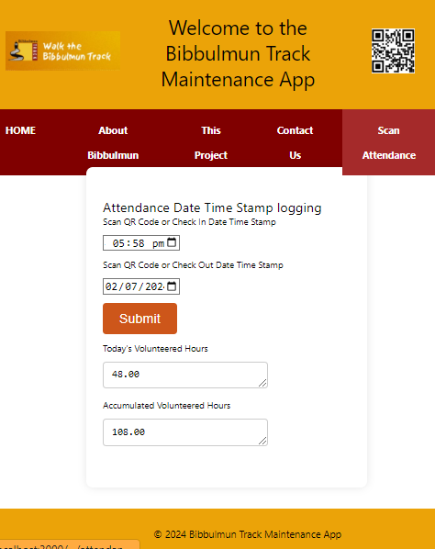

Track Maintenance Report – case report

The case report function is designed on the landing page. Therefore, even the public users who are not the registered volunteers, they can report any items upon emergency.

We design the form to enable public user to send in with their name and contact, this is also good for future development of volunteer network, the marketing staff can approach them and follow up in future.

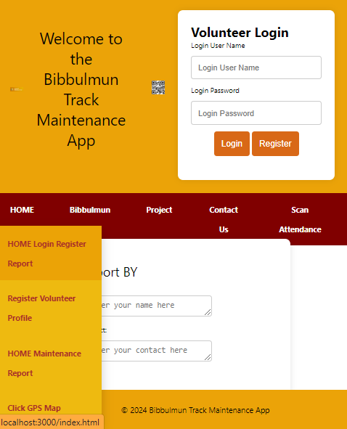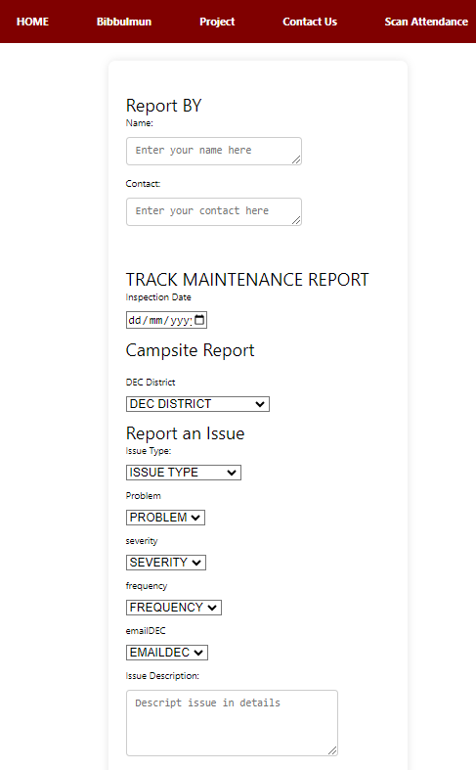

GPS function

GPS using satellite and does not rely on internet / Wi-Fi connection. Therefore, it is suitable to have this inside the Bibbulmun Track, where the user can use this to register the correct location of latitude and longitude.

Just simply click on the GET offline GPS, the latitude and longitude will be displayed with the map.

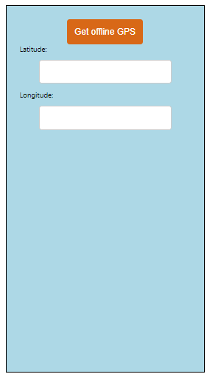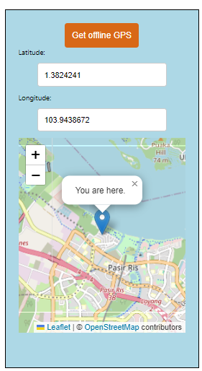

Camera and Video

The app comes with the camera and video features where the users can take numerous photos and make a few record videos, they will save the photo and video in the local storage (in their smart phone device), and synchronise all information together with the reports when they reach the place with internet connection.



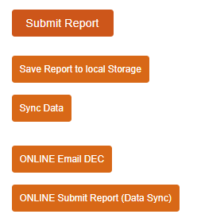

Contact Us Form

The contact us form encourage the users to reach out to the BTF marketing staff anytime for further information, or if they need to feedback / suggest something to improve constructively.
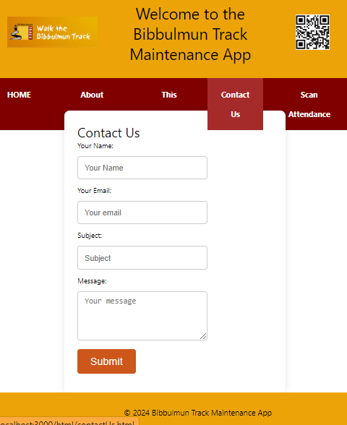

Additional software components as necessary

This robust web mobile app is handy and easy to handle without the need to install any software. Only use on the QR code to get to the correct link will do.

If necessary, it can be upload to Google Play store via Google Developer as well so users will have the convenience to download it to their smart phone.

Infrastructure requirements:

capacity

The development of this app is using “Local Storage” for Offline Data Storage to save the report, photos, and videos locally (on the device) as “Base64 strings” when the users are in the mountains without internet connection.

Estimating RAM and Storage Space:

Photos and Videos: Let's assume an average photo size is 3 MB and an average video size is 10 MB per minute.
2 Photos: 2 * 3 MB = 6 MB
2 Videos (1 minute each): 2 * 10 MB = 20 MB
Total Storage Needed: 6 MB + 20 MB = 26 MB

Smartphones nowadays typically have several GBs of storage, so 26 MB is a reasonable size.

However, for long videos, the size can increase significantly.

Suggest smart phone with a minimum of 32GB 512G since camera and videos are needed so need more memory for storage. User can use memory card to assist as well for some older phone models.

performance

It has thoroughly tested, and it complies with the majority of the client’s requests. For further details refer to the testing documents attached.

integration & compatibility

This app development fit well in the integration with the BTF current existing website.

platform strategy

Platform Strategy is a foundation or infrastructure that enables interactions between producers and consumers of value. It is tailored to our specific client’s (BTF) needs. It typically involves:

Value Proposition:

Clearly defining what are the values that the platform offers to both producers and consumers.

As the app developer, from the point of view of a student, it’s a good experience to gain an off-hand practice in creating a web mobile app right from beginning till the end. Massive researches and studies enhance our ability to work independently as well as absorbing huge volume of technical knowledge. It improves us in the practical exercise technically.

As for the consumer, in this case, this app development sponsored by the students has made good to provide the convenience and assist the volunteers in the volunteers’ management and to support their activities in making track reports.

It’s meaningful in both ways.

Network Effects:

Leveraging network effects where the value of the platform increases as more participants join, contributing to a positive feedback loop of growth.

Monetization:

Developing strategies to generate revenue from the platform, such as through transaction fees, subscriptions, advertising, or data monetization.

Ecosystem Development:

Fostering an ecosystem of complementary products, services, or applications that enhance the overall value of the platform.

Governance:

Establishing rules, policies, and standards to govern interactions and ensure trust, security, and fairness among participants.

Technology Infrastructure:

Building and maintaining the technological backbone of the platform, including APIs, data management systems, and user interfaces.

Scaling and Growth:

Planning for scalability to accommodate increasing demand and expanding the platform's reach to new markets or user segments.

Successful platform strategies often involve continuous adaptation and innovation to meet evolving user needs, technological advancements, and competitive landscapes.

security

We try to put in as much validation as we can. This is to improve the security for the user to input. This helps in reducing the unwanted debris info.

back-up & recovery

All the essential files are back-up with the same filename ended with “BK”. Should there be any file corruption, it can be retrieved and replace at the same time with no hassle.

We keep a copy of all codes in notepad attached to standby for further recovery usage.

scalability

This app is developed using cordova, extending from the BTF current existing website. It allows the greatest flexibility and convenience for scalability since it’s using hyper-text mark-up languages such as html css and javascript.

future proofing

Should there be any need for future extension, it can always add on to the site by any web mobile developers.

Discuss alternative designs

Suggest development by using Android Studio can serve the purpose as well.

Interface Design

The design of the interfaces between software modules:

The design of interfaces between software and non-human (external) entities.

The design of the interface between human and computer (HCI)

You should provide mock screen-shots of the interfaces of the system you intend to create.

Interface specifications: input/output controls, formatting, etc.

Interface Design for Bibbulmun Track App
1. Design of Interfaces Between Software Modules
The Bibbulmun Track App employs a modular design where each software component interacts through well-defined interfaces. These interfaces ensure seamless communication and data exchange between modules.

Key Software Modules:
User Authentication Module
Attendance Logging Module
GPS Tracking Module
Contact Form Module
Multimedia Capture Module
Database Module
Interface Design:
User Authentication Module -> Database Module

Input: User credentials (username, password)
Output: Authentication status (success/failure), user details
Attendance Logging Module -> Database Module

Input: User ID, check-in/check-out times
Output: Attendance record status (success/failure), calculated duration
GPS Tracking Module -> Database Module

Input: User ID, latitude, longitude, timestamp
Output: GPS data record status (success/failure)
Contact Form Module -> Database Module

Input: User ID, message content
Output: Contact form submission status (success/failure)
Multimedia Capture Module -> Database Module

Input: User ID, multimedia content (photo/video blob), associated metadata
Output: Multimedia record status (success/failure)
2. Design of Interfaces Between Software and Non-Human (External) Entities
The app interfaces with external entities such as GPS satellites and email servers.

GPS Interface:
Data Source: GPS satellites
Input: None
Output: Real-time latitude and longitude data
Email Server Interface:
Data Source: SMTP server
Input: Email content (recipient address, subject, body, attachments)
Output: Email sending status (success/failure)
3. Design of the Interface Between Human and Computer (HCI)
The HCI design focuses on providing a user-friendly and intuitive interface for the Bibbulmun Track App. Key screens include login, registration, attendance logging, GPS tracking, contact form submission, and multimedia capture.

Mock Screen-shots of the Interfaces:
Login Screen:

Registration Screen:

Attendance Logging Screen:

GPS Tracking Screen:

Contact Form Submission Screen:

Multimedia Capture Screen:

Interface Specifications:
Login Screen:

Inputs: Username, Password (text fields)
Controls: Login button, Forgot Password link, Registration link
Formatting: Formatted with responsive design for mobile and desktop views
Registration Screen:

Inputs: Name, Email, Password, Confirm Password (text fields)
Controls: Register button, Back to Login link
Formatting: Formatted with user-friendly prompts and validation
Attendance Logging Screen:

Inputs: None (uses GPS for check-in/out)
Controls: Check-in button, Check-out button, View Attendance Log link
Formatting: Simple interface with large buttons for easy access
GPS Tracking Screen:

Inputs: None (real-time GPS data)
Controls: Start Tracking button, Stop Tracking button, View Map link
Formatting: Map display showing current location
Contact Form Submission Screen:

Inputs: Message content (textarea)
Controls: Submit button, Reset button
Formatting: Clear labels and text area for easy message entry
Multimedia Capture Screen:

Inputs: Photo/Video (camera interface)
Controls: Capture Photo button, Record Video button, Save button
Formatting: Full-screen view for camera interface with easy access buttons
Conclusion
The interface design for the Bibbulmun Track App ensures a seamless user experience through intuitive HCI, well-defined software module interactions, and robust interfaces with external entities. The mock screen-shots and interface specifications provided serve as a blueprint for developing a user-centric application that meets the needs of Bibbulmun Track users efficiently.

Design Artefacts / Visuals

Data Flow Diagrams

Event Diagrams

Class Diagrams
Registration

| - IDregistration: int
| - fName: string
| - lName: string
| - email: string
| - loginPassword: string

| + register(): void
| + updateDetails(): void
| + deleteAccount(): void

Sequence Diagrams

These sequence diagrams provide a visual representation of how different components (client-side, server-side, databases, external systems) interact to execute specific functionalities within the Bibbulmun Track App. They illustrate the flow of messages and method calls between objects, helping to understand the system's behavior and communication patterns during runtime. Each diagram captures the essence of a particular feature or process, aiding in system design, development, and maintenance efforts.

User Registration Sequence Diagram

illustrates the interaction between the client-side (frontend) and server-side (backend) components when a user registers for the Bibbulmun Track App.

Title: User Registration Sequence

Participant A (Client) as Client
Participant B (Server) as Server
Participant C (Database) as Database

Client -> Server: Sends registration request
Server -> Database: Checks email uniqueness
Database --> Server: Returns email validation result
Server -> Database: Inserts user data
Database --> Server: Confirms user registration
Server --> Client: Sends registration success message

Attendance Logging Sequence Diagram

shows how attendance logging is handled, involving interactions between the client, server, and database components.

Title: Attendance Logging Sequence

Participant A (Client) as Client
Participant B (Server) as Server
Participant C (Database) as Database

Client -> Server: Sends attendance log request
Server -> Database: Saves attendance data
Database --> Server: Confirms data insertion
Server --> Client: Sends confirmation message

GPS Tracking Sequence Diagram

outlines the interaction flow for GPS tracking functionality, integrating external GPS systems with the application.

Title: GPS Tracking Sequence

Participant A (Client) as Client
Participant B (Server) as Server
Participant C (GPS System) as GPS System

Client -> Server: Requests GPS data
Server -> GPS System: Retrieves current location
GPS System --> Server: Sends location data
Server --> Client: Receives and displays location on map

Contact Form Submission Sequence Diagram

demonstrates the process of submitting a contact form and handling the submission on the server side.

Title: Contact Form Submission Sequence

Participant A (Client) as Client
Participant B (Server) as Server
Participant C (Database) as Database

Client -> Server: Submits contact form data
Server -> Database: Saves contact form submission
Database --> Server: Confirms data insertion
Server --> Client: Sends submission confirmation

Multimedia Capture Sequence Diagram
(e.g., Photo Capture, video recording)

showcases the interaction flow for capturing and saving multimedia data (photos) within the application.

Title: Multimedia Capture Sequence (Photo Capture)

Participant A (Client) as Client
Participant B (Server) as Server
Participant C (Storage) as Storage

Client -> Server: Requests to capture photo
Server -> Client: Activates device camera
Client -> Server: Sends captured photo data
Server -> Storage: Stores photo data
Storage --> Server: Confirms photo storage
Server --> Client: Sends confirmation message

Relevant Algorithms

Algorithms are fundamental to software development, whether they are explicitly defined (like sorting algorithms) or embedded within broader application logic (like data processing flows).

In the context of this web development tasks, we apply "Algorithms" typically on the following several areas, such as our “step-by-step procedures” or “sets of rules” used for calculations, data processing, or problem-solving.

Date and Time Calculations:

When calculating volunteered hours (volHours) based on Check-In (chkInDTS) and Check-Out (chkOutDTS) timestamps, essentially use an algorithm to subtract one timestamp from another to determine the duration of volunteering.

The aVolHoursMAXID textarea displays the accumulated volunteered hours.
Users first input their check-in date time (chkInDTS).
Then, they input their check-out date time (chkOutDTS).
The form submits the data for processing.
After submission, the volHours and aVolHours textareas will display today's volunteered hours and the updated accumulated volunteered hours, respectively.

Backend Logic:

While not explicitly shown in code snippets, backend Node.js scripts (like server.js) include algorithms for processing data retrieved from the frontend, handling database operations (such as INSERT, UPDATE, DELETE), and performing calculations.

Frontend Validation:

JavaScript functions used for form validation, such as ensuring chkInDTS is before chkOutDTS, involve algorithmic logic to compare dates and display appropriate alerts if conditions are not met.

Fetching and Displaying Data:

Algorithms are implicit in operations like fetching accumulated hours from a database (fetchAccumulatedHours function), where the logic involves making an HTTP request, processing JSON data, and updating DOM elements accordingly.

While these examples involve basic algorithms like date comparisons and data processing routines, more complex algorithms could be employed depending on specific functionalities.

Expanded use-case narratives

Expanded use-case narratives provide detailed descriptions of each use case scenario, including preconditions, main flow, alternative flows, and postconditions. These expanded use-case narratives provide comprehensive details for each major functionality in the Bibbulmun Track App. They describe the main flow of events, alternative flows for error handling, preconditions, and postconditions, ensuring clarity in understanding each process. This detailed approach aids in system design, development, and testing by providing a clear and structured outline of user interactions and system responses.

Here are the expanded use-case narratives for key functionalities of the Bibbulmun Track App (BTF).

1. User Registration

Use Case: User Registration
Primary Actor: User
Goal: To register a new user account in the system.
Preconditions: User accesses the registration page.

Main Flow:

User navigates to the registration page.
User enters registration details: name, email, password.
User submits the registration form.
System validates the input data:
Checks if the email format is valid.
Checks if the email is unique.
Checks if the password meets complexity requirements.
If validation is successful:
System creates a new user account in the database.
System sends a confirmation email to the user.
System displays a success message to the user.

Alternative Flows:

A1: Invalid email format
System displays an error message indicating the email format is invalid.
A2: Email already exists
System displays an error message indicating the email is already registered.
A3: Password complexity not met
System displays an error message indicating the password does not meet complexity requirements.

Postconditions: A new user account is created, and the user receives a confirmation email.

2. Attendance Logging

Use Case: Attendance Logging
Primary Actor: User
Goal: To log attendance for tracking purposes.
Preconditions: User is logged in and has accessed the attendance logging page.

Main Flow:

User navigates to the attendance logging page.
User selects the check-in option.
System captures the current date and time.
System stores the check-in data in the database.
User selects the check-out option.
System captures the current date and time.
System stores the check-out data in the database.
System calculates the duration between check-in and check-out.
System updates the attendance record with the calculated duration.
System displays a success message to the user.

Alternative Flows:

A1: User fails to check in
System prompts the user to check in before logging attendance.
A2: User fails to check out
System prompts the user to check out before logging attendance.

Postconditions: Attendance record is created and stored in the database with the duration of attendance.

3. GPS Tracking

Use Case: GPS Tracking
Primary Actor: User
Goal: To capture and display the user’s current location on the map.
Preconditions: User is logged in and has accessed the GPS tracking page.

Main Flow:

User navigates to the GPS tracking page.
User requests current location.
System interfaces with the GPS system to retrieve the current location.
System receives location data from the GPS system.
System displays the user's current location on the map.

Alternative Flows:

A1: GPS signal not available
System displays an error message indicating that the GPS signal is not available.
A2: Location permission not granted
System prompts the user to grant location access permissions.

Postconditions: User’s current location is displayed on the map.

4. Contact Form Submission

Use Case: Contact Form Submission
Primary Actor: User
Goal: To submit a contact form with user details and messages.
Preconditions: User has accessed the contact form page.

Main Flow:

User navigates to the contact form page.
User fills in the contact form with their details and message.
User submits the contact form.
System validates the input data.
If validation is successful:
System stores the contact form data in the database.
System sends a confirmation message to the user.
System displays a success message to the user.

Alternative Flows:

A1: Invalid input data
System displays error messages indicating which fields are invalid.

Postconditions: Contact form data is stored in the database, and the user receives a confirmation message.

5. Multimedia Capture (Photo Capture)

Use Case: Photo Capture / Video Recording
Primary Actor: User
Goal: To capture and store a photo within the application.
Preconditions: User is logged in and has accessed the photo capture page.

Main Flow:

User navigates to the photo capture page.
User initiates the camera to take a photo.
System activates the device camera.
User captures the photo.
System retrieves the captured photo data.
System stores the photo data in the storage system.
System displays a success message to the user.

Alternative Flows:

A1: Camera access not granted
System prompts the user to grant camera access permissions.
A2: Photo capture failed
System displays an error message indicating that photo capture failed.

Postconditions: Captured photo is stored in the storage system, and the user receives a success message.

Conclusion

The Bibbulmun Track App (BTF) is designed to enhance the experience of users tracking and reporting their activities on the Bibbulmun Track. This comprehensive system incorporates various functionalities to streamline user interactions, data management, and integration with external systems.

Key Features and Functionalities

User Registration: Allows users to create accounts securely, ensuring data integrity and providing a personalized experience.

Attendance Logging: Facilitates the logging of user attendance with precise time tracking and duration calculations.

GPS Tracking: Provides real-time location data to users, enhancing their navigation and safety on the track.

Contact Form Submission: Enables users to communicate issues or feedback directly to the organization, ensuring responsive support.

Multimedia Capture: Allows users to capture and store photos, documenting their experiences and reporting issues effectively.

System Architecture

The architecture of the Bibbulmun Track App is built on modern technologies, ensuring scalability, security, and performance.

Key components include:

Frontend: HTML, CSS, and JavaScript provide a responsive and user-friendly interface.
Backend: Node.js servers handle business logic and database interactions.
Database: MySQL stores and manages all application data, ensuring reliability and integrity.
Integration: APIs facilitate seamless communication between the frontend and backend, as well as integration with external GPS systems.

Detailed Descriptions

Each software component is meticulously designed to ensure smooth operation and maintainability. From user registration to multimedia capture, every functionality is supported by a well-defined sequence of interactions between client-side and server-side components, ensuring a robust and user-centric application.

Process and Use-Case Narratives

Expanded use-case narratives provide in-depth insights into the application's processes, detailing each step, alternative flows, and conditions. These narratives ensure a clear understanding of the system's behavior, aiding in effective development and testing.

Sequence Diagrams

Sequence diagrams illustrate the interactions between different system components, providing a visual representation of the application's workflow. These diagrams are essential for understanding the communication patterns and ensuring seamless integration between various parts of the system.

The Bibbulmun Track App is a comprehensive solution designed to meet the needs of users and administrators alike. Its robust architecture, detailed process models, and user-friendly interface make it a valuable tool for managing activities on the Bibbulmun Track. By leveraging modern technologies and following best practices in software development, the app ensures a reliable, efficient, and enjoyable user experience.

References
APA. (2022, Sept 08). APA 7th Edition Sample. Retrieved from APA: https://apastyle.apa.org/instructional-aids/reference-examples.pdf
Institute, P. M. (2024, 05 08). PMBOK® Guide. Retrieved from pmi.org.pmbok: https://www.pmi.org/pmbok-guide-standards/foundational/pmbok
Style, A. (2020). Publication Manual of the American Psychological Association, Seventh Edition (2020). Retrieved from APA Style American Psychological Association: https://apastyle.apa.org/products/publication-manual-7th-edition

Appendices

Appendix A: Deliverable Task Breakdown Statement: completed, signed, scanned and copied into document
Appendix B: Glossary/data dictionary
Appendix C: Glossary of terms and definitions and acronyms
Appendix D: Program Structure
Appendix D: Any other information you consider necessary to include

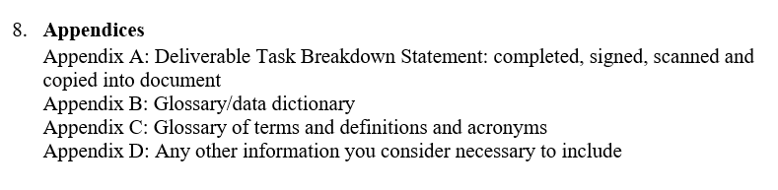

REQUIREMENT FROM LMS: Design Document Template.

Appendix A: Deliverable Task Breakdown Statement: completed, signed, scanned and copied into document

Appendix B: Glossary of terms and definitions and acronyms

BTF: Bibbulmun Track App
CRUD: Create, Read, Update, Delete
GPS: Global Positioning System
HTML: HyperText Markup Language
CSS: Cascading Style Sheets
JS: JavaScript
Node.js: A JavaScript runtime built on Chrome's V8 JavaScript engine
MySQL: A relational database management system
API: Application Programming Interface

Appendix C: data dictionary

DATA DICTIONARY

btf/www/index.html  form id="registration” | btf/www/index.html  form id =”login” | btf/www/html/contactus.html  form id="contactUs” | btf/www/index.html  form id="casereport” | btf/www/html/attendance.html  form id="attendance”
Table: registration  Columns:  IDregistration int AI PK  loginUserName varchar(20)  loginPassword varchar(8)  repeatPassord varchar(8)  fName varchar(20)  lname varchar(20)  eMail varchar(30)  hPhone varchar(20)  role varchar(10)  rLocality varchar(6)  fAddress varchar(90)  streetNumber varchar(3)  suburb varchar(10)  street varchar(30)  address1 varchar(30)  address2 varchar(30)  city varchar(5)  state varchar(20)  zipcode varchar(4)  volCat varchar(30)  tCert varchar(30)  background varchar(255)  aVolHours int  created_at datetime | Table: login  Columns:  IDlogin int AI PK  loginUserName varchar(45)  loginPassword varchar(45)  created_at datetime | Table: contactus  Columns:  IDcontactus int AI PK  name varchar(20)  email varchar(30)  subject varchar(45)  message varchar(255)  created_at datetime | Table: casereport  Columns:  IDcasereport int AI PK  idLogin int  dateTimePicker datetime  decDist varchar(30)  campsites varchar(20)  issueType varchar(20)  issuetypeoptions varchar(20)  problem varchar(3)  severity varchar(10)  frequency varchar(10)  emailDEC varchar(30)  issueDescription varchar(255)  latitude double  longitude double  photo blob  reporterName varchar(20)  reporterContact varchar(20)  created_at datetime | Table: attendance  Columns:  IDattendance int AI PK  IDregistration int  chkInDTS datetime  chkOutDTS datetime  volHours decimal(10,2)  created_at datetime

Appendix D: Program Structure

creating a web mobile app

(A) cross platform development with Node.js, Express, Cordova, MySQL SQLite MySQl BeckBench, using local storage with these features:

(1) login / registration volunteersProfile - volunteers Profile Information
(2) scan / update attendance - Volunteers Attendance Logging
(3) Track Maintenance Report - Issue Report
(4) Capture GPS and
(5) Camera video features
(6) function on smartphone offline,
(7) save the data(report) on the local data storage,
(8) data synchronise to the database when online.
(9) Issue Referrals (Refer issue to the appropriate DEC authorities automatically)

(B) focus on using node.js, do without php -->

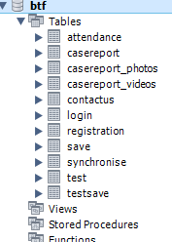 | <!--  BTF> node_modules  BTF > www > index.html  www/  ├── index.html  ├── manifest.json  │  ├──css/  │ └── form.css  │ └── header.css  │ └── index.css  │ └── leaflet.css  │ └── navigator.css  │ └── table.css  │  │── csv/  │ └── 20240512 TrackInspectionReport.csv  │  ├── html/  │ └── attendance.html  │ └── clickGPS.html  │ └── contactUs.html  │ └── headerBannerNavigator.html  │ └── loginLanding.html  │ └── registration.html  │  ├── img/  │ └── clickCamera/  │ ├── (currently no file yet)  │ └── icons/  │ ├── (currently no file yet)  │ └── BTFHomePage.jpg  │ └── BTFTrackAppQRCode.jpg  │ └── logo.png  │ └── walkTheBibTrack.jpg  │  ├── js/  │ └── app.js  │ └── attendance.js  │ └── campsiteOptions.js  │ └── clickCamera.js  │ └── clickGPS.js  │ └── clickVideo.js  │ └── contactUs.js  │ └── headerBannerNavigator.js  │ └── index.js  │ └── indexedDB.js (not in use now)  │ └── issueTypeOptions.js  │ └── login.js  │ └── loginLanding.js  │ └── registration.js  │ └── service-worker.js  │ └── indexedDB.js  │  └── uploads/  //DATABASES  MySQL Workbench > Local MySQL > Schema  ├── bibbulmun_track_app  │ └── Tables  │ ├── attendance  │ ├── casereport  │ ├── casereport_photo  │ ├── casereport_videos  │ ├── contactus  │ ├── login  │ ├── registration  │ ├── save  │ ├── synchronise  │ ├── test  │ ├── testsave  │ ├── users  └──

Appendix E: Any other information you consider necessary to include

